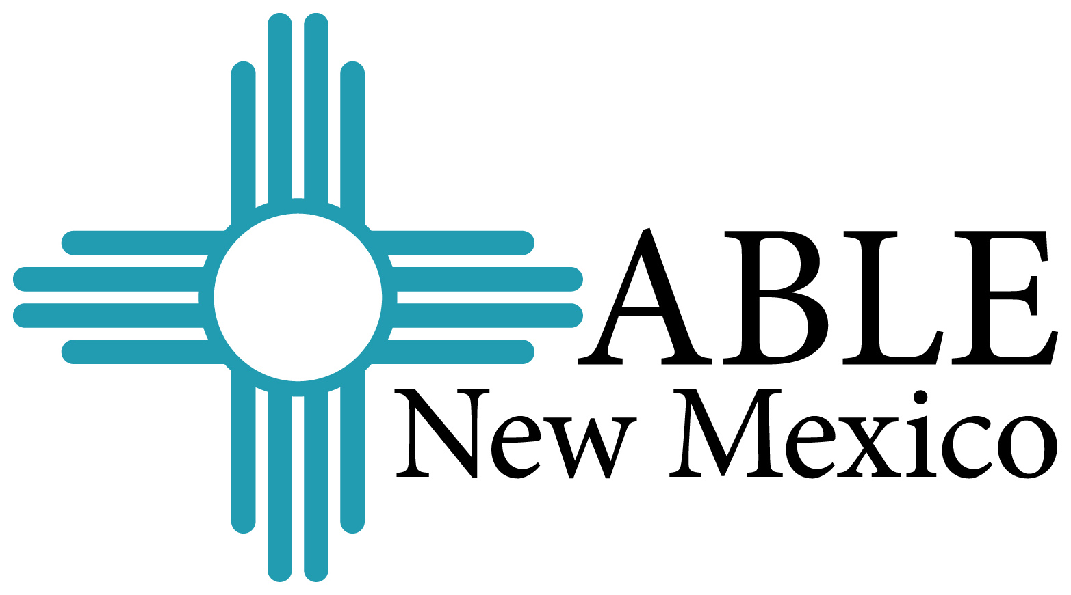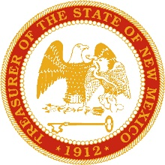

Understanding ABLE NM
Presented by:
The Office of the New Mexico State Treasurer

New Mexicans living with disabilities can now save money and keep their benefits!

August 19, 2019
4:00 p.m.
San Juan Center for Independence
1204 San Juan Blvd
Farmington, NM 87401

For more information please contact
Heather Benavidez or Denise Balderas
505.955.1136

ABLENewMexico.com ablenrc.org nmsto.gov

