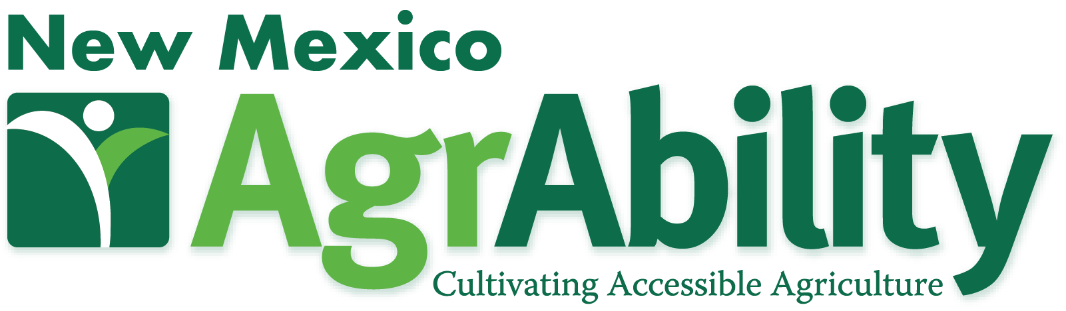
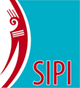
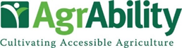
Join us for a FREE! Regional AgrAbility Event
WHAT: 1994 SIPI / AgrAbility Project Regional Workshop
WHEN: Sept. 27 & 28, 2022
WHERE: Southwestern Indian Polytechnic Institute (SIPI)
9169 Coors Blvd NW. Albuquerque, NM 87120
The event is free. You must register to attend.
Meals provided with registration.
Lodging not included (Some exceptions do apply. Please see below*)
Registration Deadline: Monday, Sept. 19, 2022
Register Here: https://rsvp.nmsu.edu/rsvp/agrability22
This event is open to everyone, especially farmers and ranchers with disabilities as well as those who support them. Hosted on the SIPI campus, this event is an effort to enhance the relationships between the AgrAbility Project and the 1994 land grant institutions. Presentations are focused on how existing, new, and prospective tribal farmers/ranchers and others with disabilities and other functional limitations can remain or become successful in small scale farming and gardening.
Join us to learn about the USDA AgrAbility project. The attached agenda includes physical rehabilitation issues of farmers and ranchers, microscale farming, adaptive tools and technology, and worksite assessment.
Day 1 offers an introduction to AgrAbility and Assistive Technology.
Day 2 features a Farmer Panel and presentations from multiple NM resource providers.
National AgrAbility Project, sponsored by the USDA, provides assistance to farmers, ranchers, other agricultural workers, and farm family members impacted by disability, illness, or chronic conditions. AgrAbility is funded through a competitive grant process establishing one National Project and multiple State/ Regional Projects (currently serving 21 states). Each state project involves a collaborative partnership between land grant universities and various non-profit disability services organizations. New Mexico AgrAbility Project is in cooperation with National AgrAbility Project, Mandy’s Farm (non-profit), New Mexico Technology Assistance Program, University of New Mexico Occupation Therapy Graduate Program and many other state, tribal, and regional organizations. National AgrAbility Project http://www.agrability.org/
Questions or more information: Chuck Baldwin, 574-306-7329 baldwi19@purdue.edu,
Sonja Koukel, 575-646-3006 sdkoukel@nmsu.edu, Robert Hagevoort 806-786-3421 dairydoc@nmsu.edu,
Milford Muskett milford.muskett@bie.edu
Program for 1994 SIPI / AgrAbility Project Regional Workshop
Day 1: Tuesday, September 27
11:00 - 12:00 Workshop Registration – NM AgrAbility Project team
12:00 - 1:00 Lunch
1:00 - 1:15 Welcome and Overview of Purpose – SIPI & AgrAbility
1:15 - 1:45 Intro to AgrAbility – Chuck Baldwin and Joe Ricker
1:45 - 2:15 New Mexico AgrAbility Project – Sonja Koukel, Robert Hagevoort, Julie LaJeunesse, Paul Ross, and Mary T Hill
2:15 - 2:45 Break
2:45 - 3:30 Rancher Bred & Grazing Options for Your Environment – John Jamerson and Joe Collards
3:30 - 4:15 Vocational Rehabilitation – Emily Martin
4:15 - 5:00 Assistive Technology – To Be Announced
5:00 - 6:00 AT Hands-on / Q&A Time / Free time
6:00 Dinner on your own
Day 2: Wednesday, September 28
7:30 Breakfast – Provided by SIPI
8:00 - 8:25 Services for Veterans in Agriculture – Joe Ricker
8:25 - 8:50 Horses for Heroes – Rev. Rick Iannucci and Alroy Billiman
8:50 - 10:15 Story Telling for Emotional/Behavioral Health and Wellbeing –
Julie Jesmer and Rachel Van Boven
10:15 - 10:30 Break
10:30 - 11:15 USDA Farm Service Agency – Joilynn Gray and LeAnn Gibbs
11:15 - 11:25 Workshop Evaluation – Chuck Baldwin
11:25 - 12:25 Farmer Panel and/or What AgrAbility Means to Me videos – New Mexico AgrAbility
12:25 - 12:30 Closing Remarks –SIPI, NM & National AgrAbility Projects
12:30 Lunch
Thank you for joining us!
SAFE TRAVELS HOME!

*Lodging Exceptions. Booking your hotel room.
Comfort Suites
5251 San Antonio Dr. NE
Albuquerque, NM
505-797-0850
505-797-7642
There is a block of rooms available the night of Sept. 27 at the discounted rate of $99. When booking your room, tell the hotel representative that this is for the SIPI-AGRABILITY CONFERENCE. Book your room before September 20, 2022.
Our Farm Credit partners are sponsoring the first 20 rooms booked on a first booked/first served basis for the first 20 farmers/ranchers or veterans traveling 50 miles or further away from SIPI.
On the registration form, please indicate if you would like to be considered for a hotel stipend for the night of Sept. 27, 2022. Note: Please make your reservation with the hotel by the Sept. 20, 2022 deadline. You will be contacted prior to the event with confirmation of your request.

